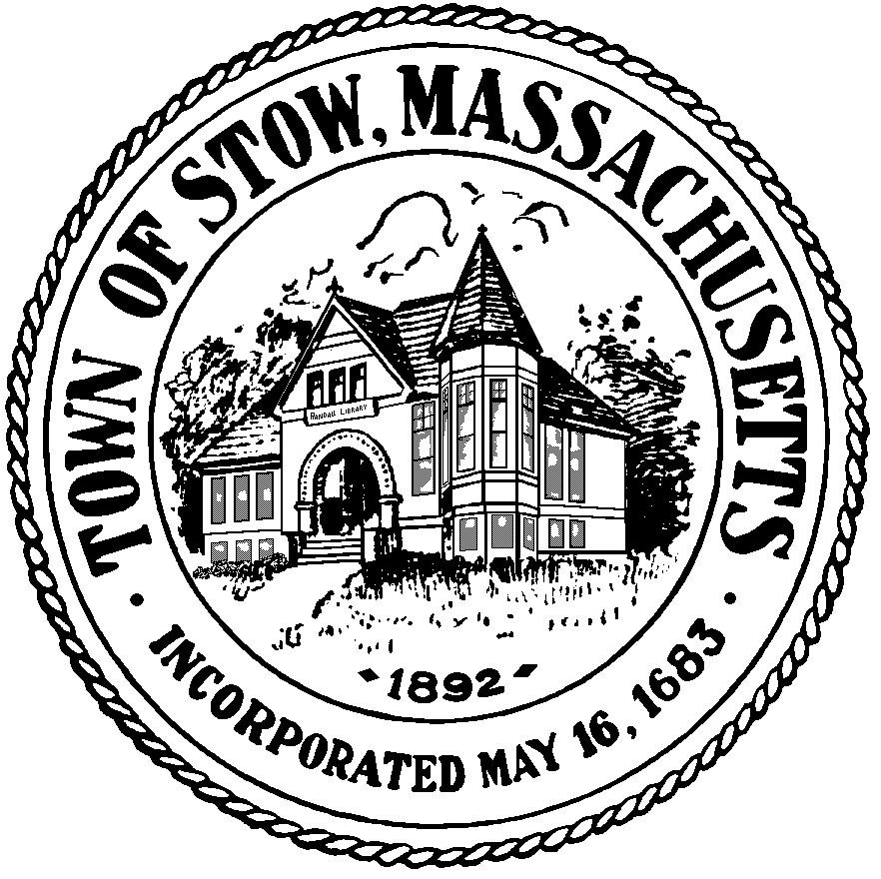

Town of Stow

community preservation committee

Agenda for May 19, 2014 7:30pm, Town Building
News & Views
Bills & Minutes
Updates on Current Projects
323 Great Road
Next Steps for 2014 Annual Town Meeting Articles/Liaison Assignments
Follow Up with Approved Projects
Summer Meeting Schedule

(posted 5/13/14)

